CLOUD BADGE:

URL: <https://www.credly.com/badges/75a6e224-9515-4605-bab8-7ed0b45dd423/public_url> 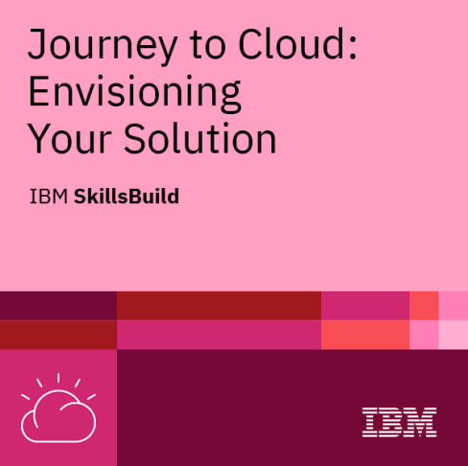

APPLIED DATASCIENCE BADGE:

url: <https://www.credly.com/badges/aa6c7406-66d4-4fd7-a345-8d107dd252e0/public_url>

